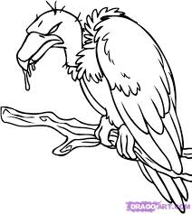
The Vulture Analysis
English III CP McCook

Write your own analysis of “The Vulture” by Franz Kafka. Identify who or what each of the following characters could symbolize:
- vulture
- protagonist (the “I” narrator)
- gentleman

- Use evidence from the text to support your analysis. Aim for at least one piece of evidence for each character.

- Your analysis should be between half a page and a full page of typed, double-spaced text. Use complete sentences and check your work before submitting it.

- You will be assessed on the creativity as well as the accuracy of your analysis.

- See the class website at kmccook.weebly.com for one modern geopolitical interpretation.

The Vulture Analysis
English III CP McCook

Write your own analysis of “The Vulture” by Franz Kafka. Identify who or what each of the following characters could symbolize:
- vulture
- protagonist (the “I” narrator)
- gentleman

- Use evidence from the text to support your analysis. Aim for at least one piece of evidence for each character.

- Your analysis should be between half a page and a full page of typed, double-spaced text. Use complete sentences and check your work before submitting it.

- You will be assessed on the creativity as well as the accuracy of your analysis.

- See the class website at kmccook.weebly.com for one modern geopolitical interpretation.

